

MetaInsight User Guide – (including Bayesian functionality) Version 1.1

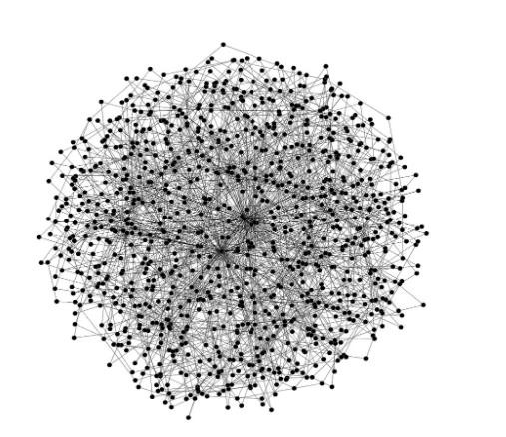

Xin Y, Cooper N, Owen RK, Freeman S & Sutton AJ

The UK NIHR Complex Review Support Unit (CRSU)

Funding information: National Institute for Health Research, Grant/Award Number: 14/178/29

MetaInsight available at:

<https://crsu.shinyapps.io/metainsight>

We delivered a webinar on MetaInsight as part of Cochrane network meta-analysis webinar series through Cochrane Training on 3rd December 2019. Professor Alex Sutton and Dr. Yiqiao Xin, presented the background of the MetaInsight development, a live demonstration (25min), and discussed related issues and future plans for the app. A recording of the webinar is available on the Cochrane Training website: .

[https://training.cochrane.org/resource/metainsight-complex-review-support-unit-crsunetwork-meta-analysis-nma-web-based-app](https://training.cochrane.org/resource/metainsight-complex-review-support-unit-crsu-network-meta-analysis-nma-web-based-app)

Alternatively, they are directly available on Youtube: Part 1: Background and introduction to MetaInsight <https://www.youtube.com/watch?v=RR_tkICQv_s&feature=youtu.be>

Part 2: Demonstration of MetaInsight <https://www.youtube.com/watch?v=b-fYoUdksRo&feature=youtu.be>

Part 3: Limitations and future plans <https://www.youtube.com/watch?v=g0n5yxQ4Z34&feature=youtu.be>We kindly ask you to cite MetaInsight whenever its output is used. MetaInsight should be cited as:

Owen RK, Bradbury N, Xin Y, Cooper N, & Sutton AJ. MetaInsight: An interactive web-based tool for analysing, interrogating and visualizing network meta-analyses using R-shiny and netmeta. Research Synthesis Methods. 2019.

<https://onlinelibrary.wiley.com/doi/full/10.1002/jrsm.1373>

This manual can be cited as:

Xin Y, Cooper N, Owen RK, Freeman S & Sutton AJ. MetaInsight User Guide – (including

Bayesian functionality) Version 0.1. Accessed from: [https://crsu.shinyapps.io/metainsight](https://crsu.shinyapps.io/metainsight_continuous2/)



Contents

 Introduction ....................................................................................................................... 4

 The home page .................................................................................................................. 6

 Using an inbuilt dataset ..................................................................................................... 7

 Illustrative example ................................................................................................... 7

 Loading your own data ...................................................................................................... 9

 Network meta-analysis (NMA) ........................................................................................ 14

 Choose data type and NMA analysis options .......................................................... 15

 Data summary ......................................................................................................... 17

 A plot of individual study results ..................................................................... 17

 Network plot .................................................................................................... 19

 Frequentist network meta-analysis ......................................................................... 21

 Forest plot ....................................................................................................... 21

 Comparison of all treatment pairs .................................................................. 23

 Inconsistency ................................................................................................... 24

 Bayesian network meta-analysis ............................................................................. 25

 Forest plot ....................................................................................................... 25

 Comparison of all treatment pairs .................................................................. 28

 Ranking table ................................................................................................... 28

 Nodesplit model .............................................................................................. 30

 Bayesian result details ..................................................................................... 31

 Deviance report ............................................................................................... 33

 Model details ................................................................................................... 37

 Perform sensitivity analysis ..................................................................................... 38

 Sensitivity analysis: network plots .................................................................. 39

 Sensitivity analysis: forest plots ...................................................................... 40

 Sensitivity analysis: comparison of all treatment pairs ................................... 42

 Sensitivity analysis: ranking ............................................................................. 43

 Sensitivity analysis: Inconsistency ................................................................... 45

 Sensitivity analysis: Bayesian details and deviance report ............................. 47

 Output results .......................................................................................................... 49

 Acknowledgement ........................................................................................................... 51

 Full list of packages .......................................................................................................... 51

 References ....................................................................................................................... 51

# Introduction

*MetaInsight* is an interactive web-based application for conducting network meta-analysis and was developed by the NIHR Complex Review Support Unit (CRSU). In clinical settings, there are often more than two available intervention options. Traditional meta-analysis, or ‘pairwise meta-analysis’ compares two interventions and therefore is limited in its ability to answer questions when three or more interventions are compared. Network meta-analysis (NMA) aims to evaluate multiple (n>2) interventions that may or may not have been directly compared in the studies. This approach combines studies making different intervention comparisons, that together form a connected network of evidence, to obtain relative treatment effects for all interventions compared to one another. NMA has been increasingly adopted in recent years by Cochrane reviews, guideline developers and decision-making bodies such as National Institute of Heath and Care Excellence (NICE) in the UK to address the questions such as ‘which intervention is the ‘best’ overall?’. Further information on NMA is available elsewhere (1-4).

Currently, NMA is primarily conducted in statistical packages such as WinBUGs, R and STATA, and depending on the packages chosen, the software coding can be difficult for non- statisticians and hinders the progress of carrying out systematic reviews containing NMA. It revealed a need for the development of a user-friendly interface to sustainably increase capacity by empowering informed non-specialists to be able to conduct more clinically relevant reviews. To this end, MetaInsight was created, although it has also been found to be a user-friendly and time-saving tool for the more experienced analyst.

*MetaInsight* is freely available and requires no specialist software, beyond a modern web browser, for the user to install but leverages established analysis routines. The tool is interactive and uses an intuitive ‘point and click’ interface and presents results in visually intuitive and appealing ways. It can also carry out sensitivity analysis on existing NMAs. It is hoped that this tool will assist those in conducting NMA, and, in turn, increase the relevance of published meta-analyses.

The tool can interactively conduct NMA for both binary and continuous outcomes for fixed and random effects models [12] and facilitates sensitivity analyses via the inclusion and exclusion of studies. It allows users to upload their own datasets into a webpage and provides graphical representations of the treatment network and various aspects of the comparison results. This includes forest plots of individual studies, forest plots of pooled analysis results, comparison between pairwise results and network results for each of the comparisons, ranking of interventions, and inconsistency tests.

MetaInsight has been built primarily using the Shiny (5), netmeta (6) and GeMTC (7) packages for R. Shiny allows users to build interactive web applications and host them on a server. The statistical analysis is conducted using the packages netmeta or GeMTC. A full list of all R packages used in the building of MetaInsight can be found in Section 7.

We initially developed the app for conducting frequentist NMA only. In October 2019 MetaInsight version 2 was released which, in addition to the frequentist NMA, enables Bayesian NMA to be conducted. Within each version, there were separate Apps for continuous outcomes (e.g. weight change) and binary outcomes (e.g. success rate). In April 2020, we further integrated the two Bayesian apps together into one app.

The link to the MetaInsight (including Bayesian estimates) V3 is as below:

• <https://crsu.shinyapps.io/metainsight/>

In this User Guide we will demonstrate the features available within MetaInsight version 3** Beta. We will start by showing you the home page and how you can upload your own dataset to MetaInsight and then demonstrate the features of MetaInsight using one of the inbuilt datasets allowing you to replicate the analysis if you wish. MetaInsight consists of five pages (Home, Load Data, Data analysis, Full update history, and Privacy notice) which can be accessed by clicking on the appropriate page name in the grey bar at the top of the web page. This User Guide will guide you through each page in turn.

If you have any feedback or queries about MetaInsight, please feel free to contact Professor Alex Sutton ajs22@leicester.ac.uk.

# The home page

The MetaInsight (continuous outcome version) home page is shown in Figure 1. The name indicates the version number v 3** Beta. A radiobutton is displayed underneath the title for users to select the outcome of their analysis. On the right of the diagram, it highlights the new features since last update. Below the diagram you can find the authors, contact email, packages used, and disclaimers from the authors.

*Figure*

*1*

*Home page of MetaInsight V3*

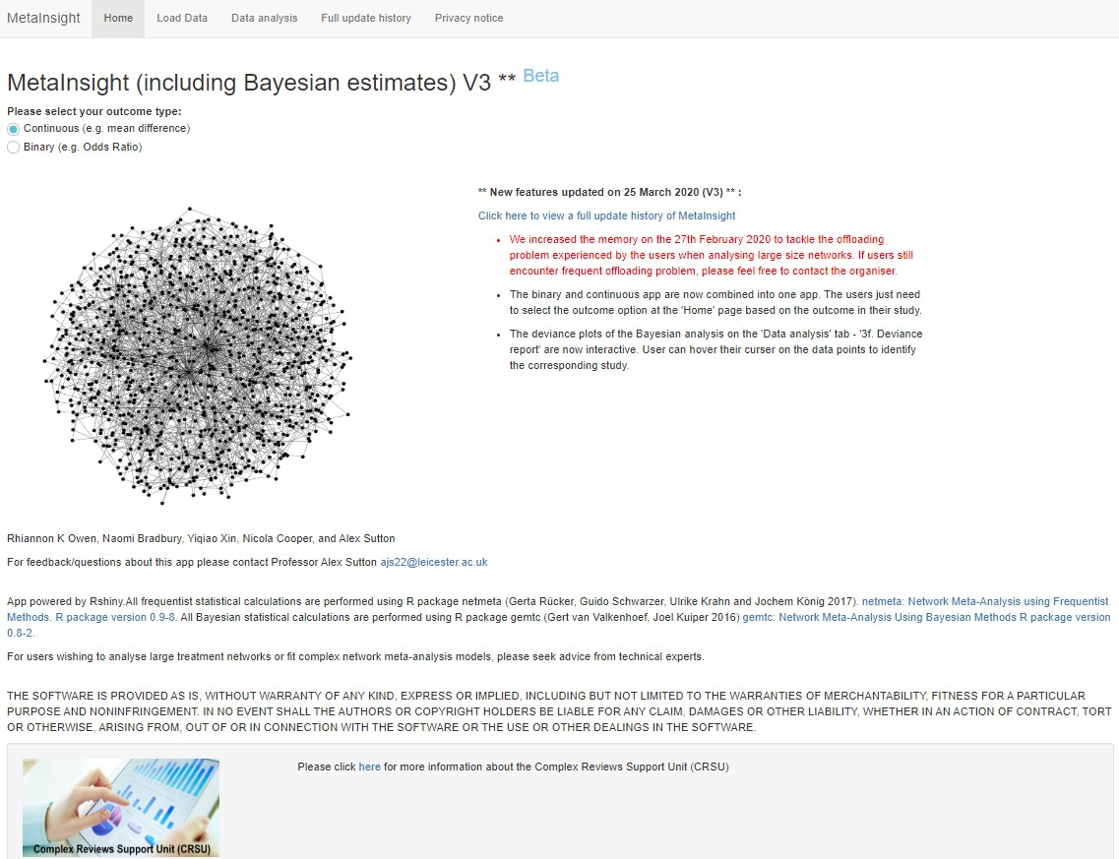

Navigate to a page using the

grey bar at the top of the page



Outcome selection. Please make

sure this is selected according to

the outcome of your interest.

# Using an inbuilt dataset

MetaInsight comes with one inbuilt dataset each for its continuous outcome example and binary outcome example, which can be used to familiarise yourself with the features of MetaInsight. The datasets are available to download in csv format and can be used to help ensure that your own data is in the correct format for upload to MetaInsight.

*Figure*

*2*

*Downloading inbuilt dataset*

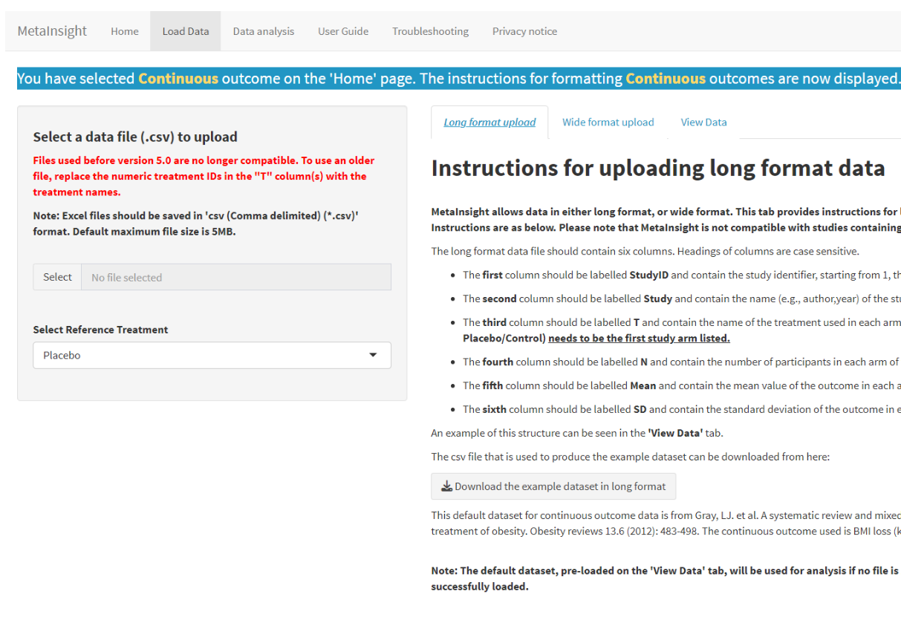

Download the example

inbuilt dataset to assist

with formatting



## Illustrative example

Throughout the remainder of this User Guide we will use the inbuilt dataset. This dataset is from a systematic review and NMA of pharmacological interventions for the treatment of obesity. The example dataset evaluated change from baseline in body mass index (BMI) for anti-obesity interventions (8). The dataset consists of 24 studies evaluating (in various combinations) the effectiveness of 6 interventions of interest - placebo, orlistat, sibutramine, metformin, orlistat + sibutramine, and rimonbant. Twenty of these studies were 2-arm trials, 3 studies were 3-arm trials, and one study was a 4-arm trial. All studies reported estimates of mean difference from baseline in BMI, together with its corresponding uncertainty. The dataset can be downloaded by clicking the download button and the resulting CSV file is shown in Figure 3.

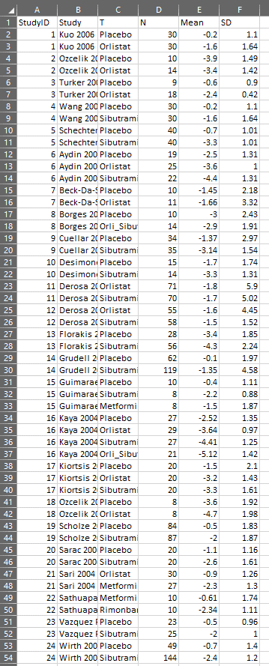

*Figure 3 Screenshot of csv file resulting from downloading the dataset in long form.*

# Loading your own data

The ‘Load Data’ page consists of a grey box on the left-hand side of the page and three tabs: Long format upload, Wide format upload, and View data (Figure 4). Users can import their data easily by uploading a comma delimited (.csv) file in either long or wide format. The first row of the data file should contain the column headings. Column headings are specified on either ‘Long format upload' or ‘wide format upload’ tab. To assist with the labelling of column headings inbuilt example datasets are available to download as previously mentioned.

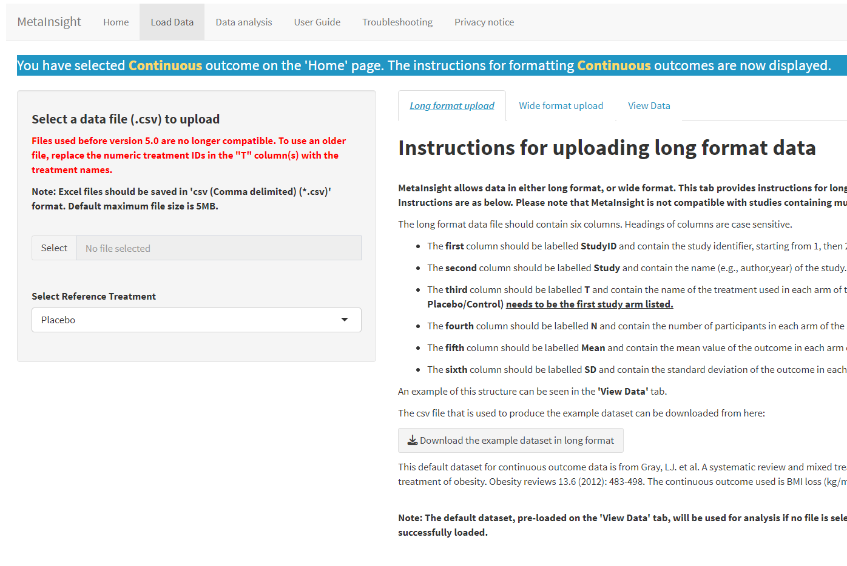

*Figure 4 Load data page of MetaInsight V3*

For the continuous app, the long format data would require six columns containing the ‘Study ID’ (as sequential and numerical code), ‘Study’ name, treatment name ‘T’, the number of participants ‘N’, the mean treatment effects ‘Mean’ and corresponding standard deviations ‘SD’ for each arm of the study. The wide format data would include ‘Study ID’, ‘Study’, and sets of ‘T’, ‘N’, ‘Mean’ and ‘SD’ depending on the number of arms (i.e., ‘T.1’…‘T.6’, ‘N.1’… ‘N.6’, ‘Mean.1’…’Mean.6’, ‘SD.1’…’SD.6’).

For the binary outcomes, the long format data would require five columns containing the ‘Study ID’, ’Study’ name, treatment name ‘T’, the number of participants with the outcome of interest in each arm of the study ‘R’, and the number of participants in each arm of the study ‘N’. Similar to the wide form with the continuous outcomes, the wide format data would include ‘study ID’, ‘Study’ and sets of ‘T’, ‘R’ and ‘N’ depending on the number of arms (i.e., ‘T.1’… ‘ T.6’, ‘R.1’…’R.6’, ‘N.1’…’N.6).

An example of long and wide format data entry is given in Figure 5 and Figure 6. MetaInsight will try to detect the most likely reference treatment, but it can be manually defined by selecting from the drop-down box below the fie upload. The reference treatment is the treatment option that all the other treatments will be compared to in the analysis. The reference treatment is usually either a placebo or usual care group, or the most common comparator used in the included studies. In this example, the reference treatment is placebo.

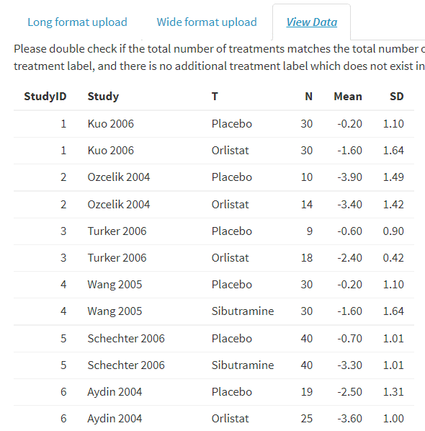

*Figure 5 Upload data to the MetaInsight app - Long data format*

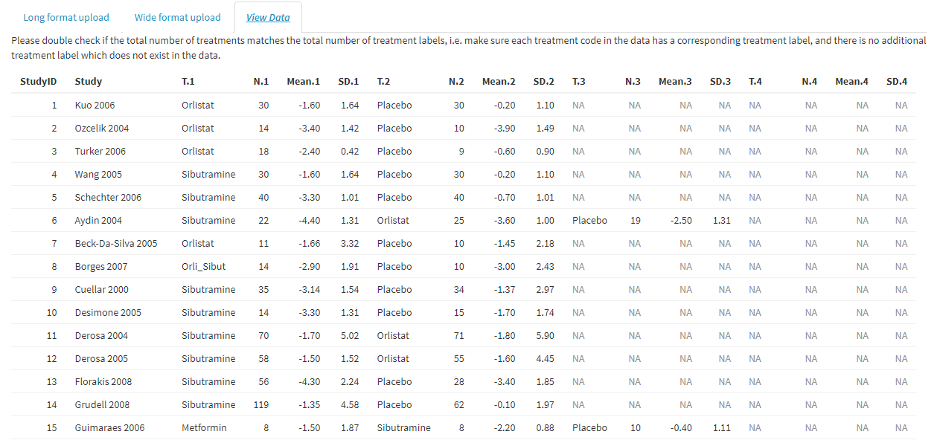

*Figure 6 Upload data to the MetaInsight app – Wide data format*

To load your own dataset:

1. **Formatting**: Follow the instructions on either ‘long format upload’ or ‘wide format upload’ subtabs to format your data. Please feel free to download the example inbuilt dataset for each type of format to assist labelling.
2. **Saving:** Save your formatted data as ‘csv (Comma delimited) (*.csv) format.
3. **Uploading:** Click the `Select' button at the left of the grey box (Figure 4). A box will appear which will allow you to navigate through your computers file system until you find the file you wish to upload. Select the file you wish to upload and click open. Once the upload is completed a blue bar will appear showing `Upload complete' (Figure 4).
4. **Checking**: Click on the `View data’ tab if you want to check your dataset has uploaded in the format expected (Figure 5 or Figure 6).

These steps are shown in Figure 7.

Please note: The `View data’ tab will always display the dataset that is currently loaded and used for analysis within MetaInsight. Prior to upload of your own dataset, this tab will display the inbuilt default dataset.

Helpful Hints for uploading your own dataset to avoid error messages:

* Excel spreadsheets must be saved in comma delimited (csv) format before uploading to MetaInsight
* The labelling of column headings is case sensitive
* The ‘Study’ field should be unique for every study; in wide form, it should be unique for every row.

# Network meta-analysis (NMA)

Once the data are uploaded, click on ‘Data analysis’ at the top of the page (Figure 9) and you will see a page with a side bar on the left and a main section on the right. The side bar contains the choices relevant to your data, and the NMA analysis options (see section 5.1). The main section contains the following tabs for data summary (see section 5.2), frequentist NMA analysis results (see section 5.3) and Bayesian NMA analysis results (see Section 5.4):

1. Data summary, which contains two subtabs:

1a. Study Results, and

1b. Network Plot, and

1. Frequentist network meta-analysis, which contains three subtabs:

2a. Forest plot, and

2b. Comparison of all treatment pairs, and

2c. Inconsistency

1. Bayesian network meta-analysis, which contains seven subtabs:

3a. Forest plot

3b. Comparison of all treatment pairs

3c. Ranking table

3d. Nodesplit model

3e. Bayesian result details

3f. Deviance report

3g. Model details

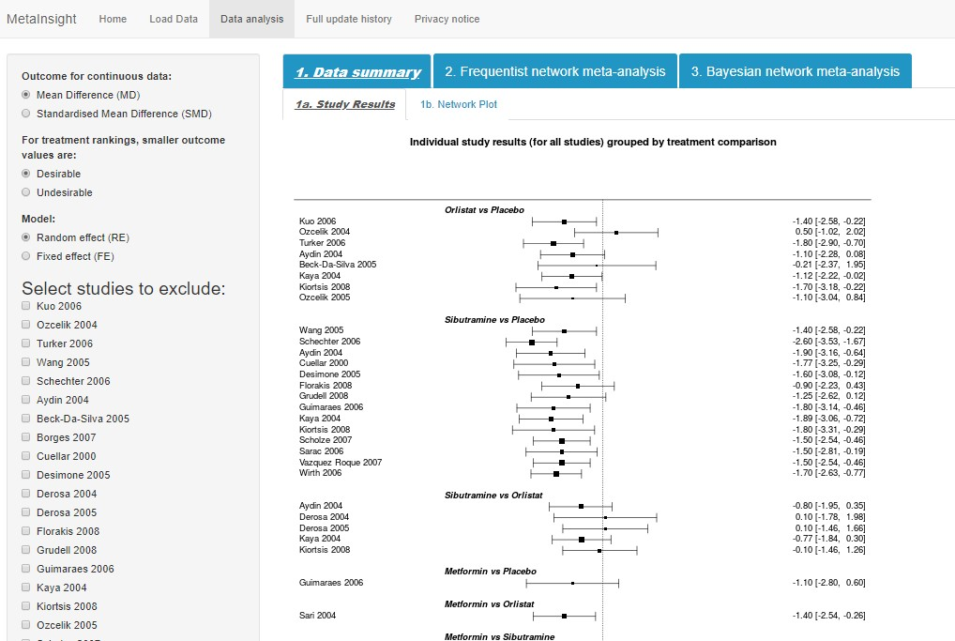

*Figure 9 Data analysis tab of the MetaInsight V3*

## Choose data type and NMA analysis options

Firstly, select the outcome relevant for your data type. In this example, we have continuous data and our outcome of interest is the Mean Difference in BMI, and therefore we leave the radio button selected as the default, ‘Mean Difference (MD)’ (Figure 10). If your outcome of interest is standardised mean difference, then ‘standardised mean difference (SMD)’ should be selected. Figure 11 shows the interface of the ‘Data analysis’ tab with binary outcomes where three outcomes can be selected from: odds ratio (OR), risk ratio (RR) and risk difference (RD).

For the treatment rankings, the user must specify whether smaller outcome values are desirable or undesirable. In this example, as the outcome is change in BMI, smaller (negative) values indicate a reduction in BMI and thus we select ‘desirable’. Similarly, this applies to other clinical outcomes such as blood pressure lowering drugs for hypertension or cigarette per day for smoking cessation. Examples for the opposite situation where you would need to select ‘undesirable’ includes outcomes such as steps per day for interventions that aims to increase physical activities, quality of life measurement where usually a higher score indicates better quality of life.

Finally, the user will need to select the type of NMA model to fit to the data – fixed or random effects. Fixed effect model assumes that the true effect size does not vary between studies, whereas random effect models assumes that the true effects in each individual study are sampled from a distribution. (9) The default is random effect (RE).

Underneath the choices for data type and model options is the study selection section (Figure 10). One of the best features of the MetaInsight app lies in its convenience for conducting sensitivity analysis by excluding one or more studies from the main analysis from the sidebar and results are displayed side by side with the all-inclusive primary results. Studies can easily be excluded from the analysis using a simple checkbox interface. The user can choose to exclude one or more studies and the NMA will be updated and displayed alongside the complete case analysis which remains visible to facilitate comparison. There are three caveats in terms of study exclusion:

1. If the reference treatment is excluded completely from the analysis (i.e. all the studies that contain the reference treatment are excluded), the user will need to renumber the treatments, i.e. to remove treatment 1 on the treatment code editing box shown in ‘step 2’ on page 11. If any other treatment is excluded, the results should display with no need to relabel.
2. If the network becomes disconnected due to exclusion of studies, both the network plot and the frequentist results will show error messages. If this happens, users are advised to check their network and continue excluding studies until only one connected network exists and all other disconnected studies have been selected for removal. The app will update each time a new study is excluded; this means the app will automatically show results after the cause of the error (the disconnected network in this case) has been addressed.
3. If studies were excluded until only two treatments existing in the network, the frequentist analysis is still able to perform the pairwise meta-analysis.



Choices for data type, direction

of preferences of outcome, and

NMA model

. Note the two

options for a continuous

outcome: mean difference and

standardised mean difference

Study selection section:

The user can

choose to exclude one or more studies

and the NMA will be updated and

displayed alongside the complete case

analysis which remains visible to

facilitate comparison.



*Figure 10 Choices for data type and NMA analysis options with continuous outcomes*

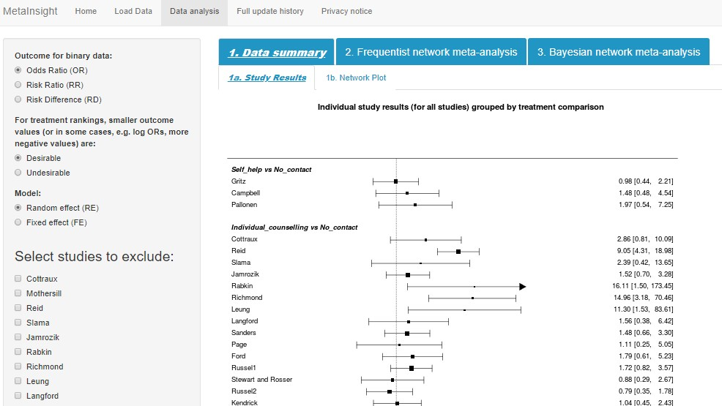

Choices for data type, direction of

preferences of outcome, and

NMA model. Note the three

options for binary outcomes: odds

ratio, risk ratio, and risk

difference.



*Figure 11 Choices for data type and NMA analysis options with binary outcomes*

## Data summary

The ‘1. Data summary’ page contains two subtabs (Figure 12):

* ‘1a. study results’, and
* ‘1b. network plot’.

### A plot of individual study results

‘1a. Study Results’ contains a plot of the individual study results as included in the NMA grouped by each pairwise treatment comparison. These study results are displayed on a common scale in a forest plot (Figure 12). Please note this forest plot does not display any pooled results. It only provides a visualisation of the individual study results based on the uploaded data.

There are two pieces of key information you can see from observing this plot. Firstly, it informs how much evidence there is for each comparison. For this specific example, there are a lot of studies comparing orlistat versus placebo, sibutramine versus placebo, and sibutramine vs. orlistat, but not much evidence for the other comparisons.

Secondly, users can examine the results from each individual study within each of the comparisons to visually examine the degree of heterogeneity between studies and identify potential ‘outliers’ that the user may wish to examine further or exclude from the analysis as part of the sensitivity analysis. A visual inspection of the treatments for obesity example shows the study results for the sibutramine vs placebo comparison to be similar with almost all studies showing a statistically significant reduction in BMI with sibutramine compared to placebo. While for the orlistat vs placebo comparison, the majority of studies show orlistat to be more effective than placebo (i.e. the mean effect estimate is negative showing a reduction in BMI) but with many of the 95% confidence intervals crossing the line of no effect.

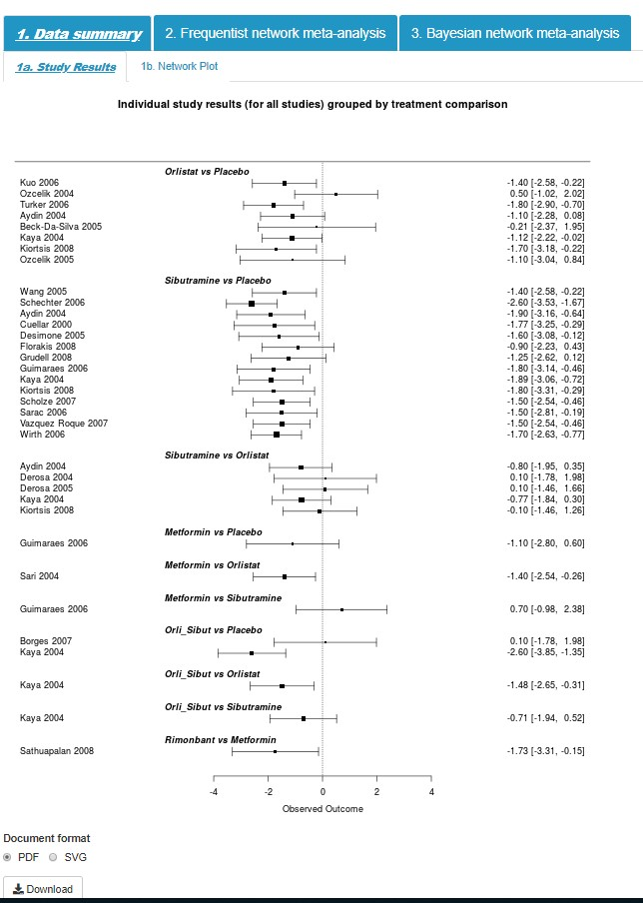

*Figure 12 Forest plot of individual study results grouped by treatment comparison.*

### Network plot

Click on the ‘1b. network plot’ and you will see two network diagrams; on the left is the network plot of all studies and on the right is the plot for the sensitivity analysis (See section 5.5).

These network plots provide a visual display of where interventions have been compared in head-to-head trials, and importantly whether there is a connected network of evidence; an essential requirement for NMA. Each node on the plot represents an individual intervention with connecting lines between nodes indicating where one or more of the trials have evaluated both interventions on a head-to-head basis. The number along the lines indicates the number of trials making each comparison.

Initially, the two network plots will be identical but if studies are excluded by clicking on their study names on the left sidebar, the user will see the numbers on the network plot on the right change as these depict the number of studies for each intervention comparison in the NMA. The structure of the network plot may also change if by excluding studies data on a particular treatment comparison is no longer available, as shown on Figure 13.

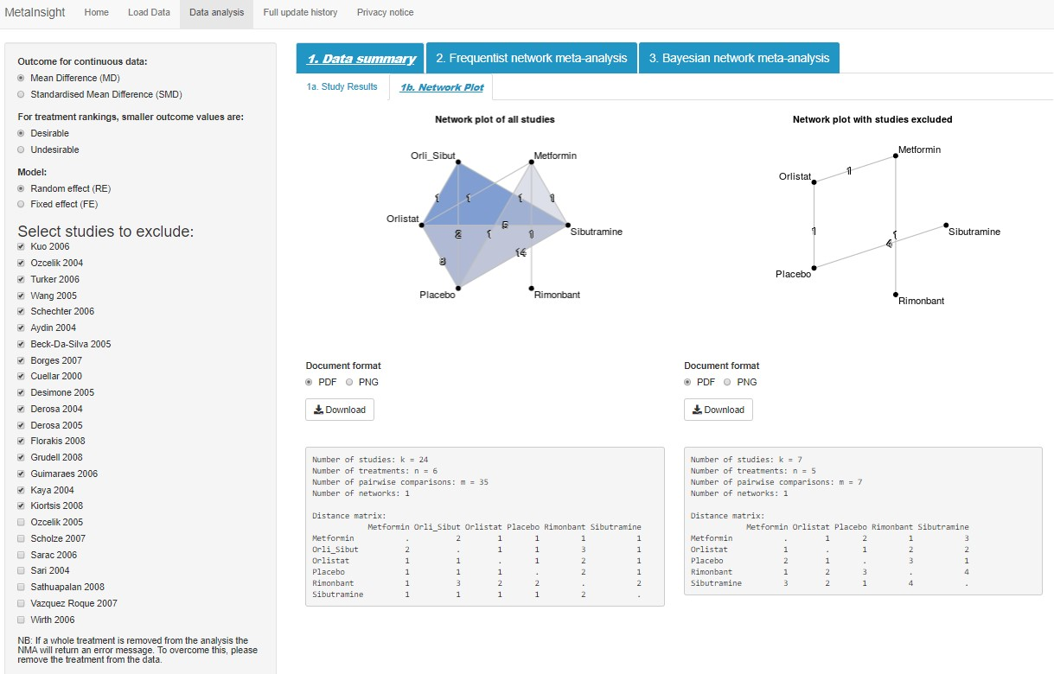

Study selection

Network plots



*Figure 13 A network plot of all studies and network plot with studies excluded*

Underneath each network plot is the plot information box (Figure 14). In this example, it shows there are 24 studies, comparing 6 treatments, forming 35 pairwise comparisons and there is one connected network.

The distance matrix shows how two treatments are connected in the network. The lower triangle and the upper triangle display the same information, so users only need to look at one of them. When the distance is 1, it indicates that direct evidence exists between that comparison, or graphically, there exists an instance where one line connects the two treatments (for example, metformin vs orlistat in the left network plot) (note, longer routes between the treatments may also exist). When the distance is 2, it means the shortest connection between the two treatments is through another comparator, or graphically, there are two lines needed to connect the two treatments (for example, metformin vs. orli_sibut in the left network plot). You can see that there is one 3 distance in the matrix, which is between rimonbant and orli_sibut indicating that the shortest distance between these two treatments is through another two treatments, or at least three lines are needed to connect them. The distance matrix provides a good way of checking the network and allows the users to assess the degree of the ‘indirectness’ between any two interventions.

*Figure*

*14*

*network plot information box*

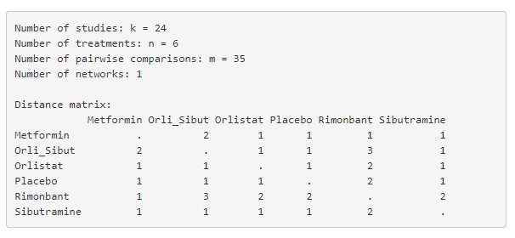

Distance 3: the shortest distance

between rimonbant and

orli_sibut is through another

two treatments.

In some cases, if the network is disconnected (i.e., two or more disconnected subnetworks exist), the network plot will not be produced, and the app will give error messages. If this happens, then the network information box will show the ‘number of networks’ to equal 2 instead of 1This is shown in Figure 15. If disconnection happens, the users could try excluding all the studies in one network, then the plot and the results for the other network should appear. One caveat to this is that if the reference treatment is contained in a disconnected subnetwork that has been completely removed, the user will need to renumber the treatments to make one of the remaining treatments the ‘new’ reference treatment to enable the analysis to run.

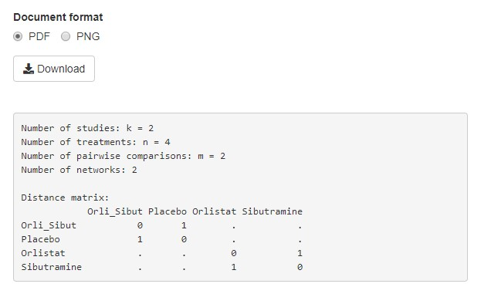

Error message is produced for

the network plot since there are

two disconnected networks.

*Figure 15 Using network plot information to detect disconnected networks*

## Frequentist network meta-analysis

After examining the forest plot of individual study results and the network plots, click on the ‘2. Frequentist network meta-analysis’ tab where three subtabs are displayed:

### 2a. Forest plot

2b. Comparison of all treatment pairs

2c. Inconsistency

These tabs display key results produced from the R netmeta package. On each tab, the results for all studies and for sensitivity analysis are displayed side by side, which enables an immediate comparison to examine the impact of excluded studies. The result is immediately shown once you click each tab name. The functions of each tab are described as below.  **Forest plot**

The ‘2a. forest plot’ tab displays the forest plot of the pooled effect estimates, and their associated uncertainty (95% confidence intervals), for all interventions compared to the reference treatment (coded as treatment 1 on the ‘Load data’ page – placebo in this example).

Figure 16 shows the plot displayed by the default options, i.e. mean difference (as displayed ‘MD’) in the heading for the mean pooled estimates, and random effects model (as displayed under the title).

Key information is displayed below the forest plot, including the between-study standard deviation (‘tau’, indicating how much heterogeneity there is), the number of studies, and the number of treatments in the meta-analysis. The results for this example show rimonbant has the largest pooled mean difference as compared to placebo (the reference treatment); rimonbant appeared to decrease BMI by approximately -3.76 kg/m2. Despite having the largest mean difference, the confidence interval is relatively wide (95%CI: -5.52, -1.99). This is likely to be caused by the lack of evidence for rimonbant, which can be seen from the network plot in Figure 13 that there is only one study (only one line linking the node rimonbant to the network, with one study for that comparison) evaluated rimonbant (Rimonbant vs. Metformin). If we remove that study (by checking the treatment code from the ‘data analysis’ tab on the ‘load data’ page), we will get a new NMA with only five treatment options in the network (see the forest plot on the right of Figure 16). This, however, does not change the pooled estimates for other interventions versus placebo as the connection with rimonbant is not in any of the loops within the network. In this way, the MetaInsight produces a good platform for interrogating the analysis and checking the impact of individual studies on the results.

*Figure*

*16*

*Forest plots*

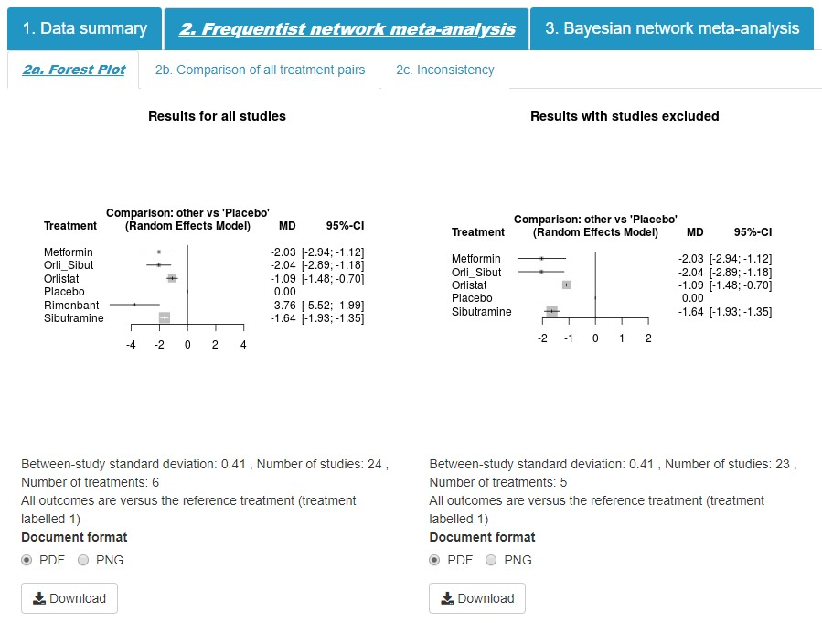

### Comparison of all treatment pairs

Clicking on the tab ‘2b. comparison of all treatment pairs’ produces a matrix of all the comparisons in a network meta-analysis. As for the previous tabs, the top matrix displays results with all studies included, and the bottom league table displays results with studies excluded. Above the leading diagonal, in the upper triangle, are the treatment comparisons obtained from pairwise meta-analyses only (i.e., with only direct head to head evidence). These are calculated as the treatment in the row versus the treatment in the column. For example, the pooled mean difference from pairwise analysis of rimonbant (row) versus. Metformin (column) is -1.73 (95%Crl -3.24, -0.22). Below the leading diagonal, in the lower triangle, are the treatment comparisons obtained from the network meta-analysis. These are calculated as the treatment in the column versus the treatment in the row. Both pairwise and network estimates are presented as point estimates and corresponding 95% confidence intervals.

The interventions are ordered from the most effective intervention to the least effective intervention along the leading diagonal (Figure 17). The ranking is dependent on the choice buttons on the side bar; for this example, a smaller BMI means the treatment is more effective, and therefore we leave the selection as default, ‘smaller outcome values are desirable’. If we change the selection to ‘undesirable’, the order would change to the opposite on the leading diagonal with placebo being the best treatment.

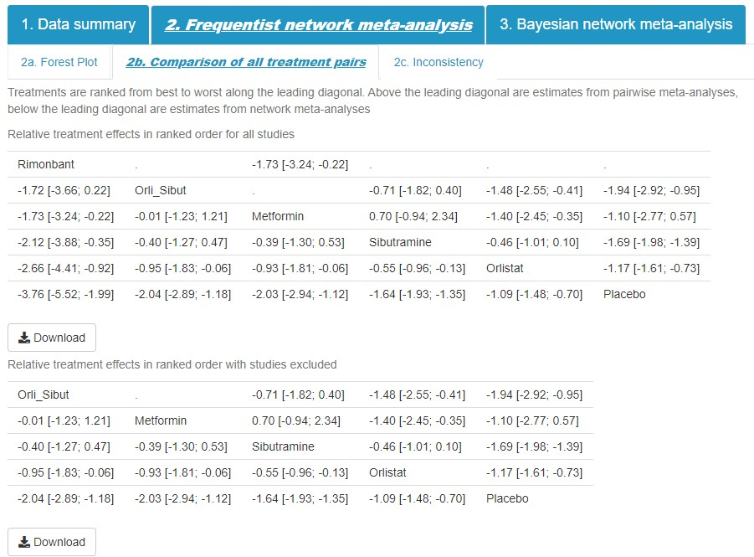

*Figure 17 Comparison of all treatment pairs*

### Inconsistency

Clicking on ‘2c. inconsistency’ provides the inconsistency tests results (obtained using the netmeta package) (Figure 18). Consistencies between treatment effect estimates obtained from direct and indirect evidence are one of the key assumptions underpinning NMA. The inconsistency table displays the agreement between the direct evidence and indirect evidence including: the number of studies directly comparing treatments of interest (‘No. Studies’), NMA treatment effect estimates (‘NMA’), treatment effect estimates obtained from direct (i.e. head to head) comparisons (‘Direct’), and treatment effect estimates obtained from indirect information (‘Indirect’). For treatments that belong to a closed loop in the network of evidence (i.e. there exists both direct and indirect information), the difference between the direct and indirect estimates is calculated together with the lower and upper limit of the 95% confidence interval (‘difference’, ‘Diff_95CI_lower’ and ‘Diff_95CI_upper’). Differences between direct and indirect information are further quantified using p-values where a low p-value can be used to indicate conflicting evidence unlikely to be attributable to chance alone (‘pValue’). In the example (Figure 18, we can see that there does not appear to be any important estimated differences between direct and indirect information (although power is often limited in such assessments).

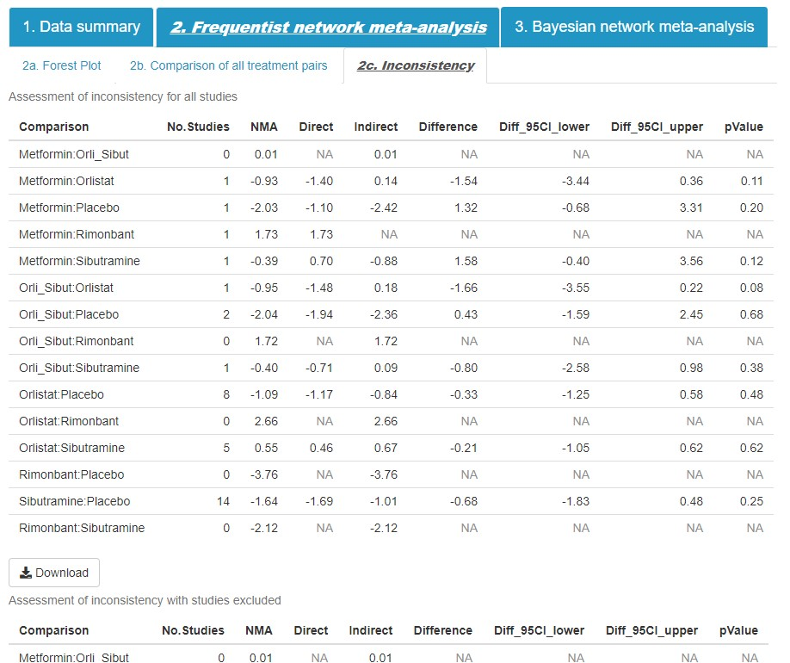

*Figure 18 Assessment of inconsistency*

## Bayesian network meta-analysis

The Bayesian NMA is conducted with the R package GEMTC that itself calls the Bayesian simulation analysis software JAGS ([http://mcmc-jags.sourceforge.net/)](http://mcmc-jags.sourceforge.net/).

Under the ‘Data analysis’ tab, click on ‘3. Bayesian network meta-analysis’. The tab names and their functions under the Bayesian NMA are summarised in Table 1 below.

*Table 1 Bayesian NMA functions*

|  |  |
| --- | --- |
| Tab names | functions |
| 3a. Forest plot | Forest plot of the Bayesian NMA results (each treatment compared to the reference treatment), and model fit statistics |
| 3b. Comparison of all treatment pairs | Estimates of comparison of all treatment pairs from the NMA |
| 3c. Ranking table | Ranking table and median rank chart for each treatment to be the best |
| 3d. Nodesplit model | Inconsistency tests with a “node-splitting” model (assesses whether the direct and indirect evidence is inconsistent) |
| 3e. Bayesian result details | Direct simulation result output from R including mean, SD and quantiles from the iterations for each treatment effect, and Gelman convergence assessment plot for checking model convergence. |
| 3f. Deviance report | Three plots are provided for checking model fit of individual data points: a. residual deviance from NMA model and UME inconsistency model (please see section 5.4.6 for details), b. perarm residual deviance for all studies, c. leverage plot. Deviance data output are displayed at the end of the page. Studies with outlying results can be identified using these tools |
| 3g. Model details | 3g.1 – model codes (adds transparency for what the app is doing “behind the scenes”).  3g.2 – initial values: initial values used in each of the four simulation chains for the analysis.  3g.3 – Download simulations: simulated result data are available to download (e.g. to import into other packages). |

Now we will illustrate these functions below.

### Forest plot

The Bayesian method uses an approach where it runs Markov chain Monte Carlo simulations and calculates the estimated model parameter distributions empirically. Because the simulations take much longer time and memory to run than the frequentist approach

(currently it runs 25,000 sample iterations in total), we added the running buttons as seen in Figure 19. Whenever the users change the radio button selections on the side bar, no matter which tab the users are at, it is necessary to go back to the ‘forest plot’ page and click this button to re-run the analysis. This is different from the frequentist analysis, where for example, if you select a few studies to exclude, the app will immediately start running after each additional study is selected, but in the Bayesian analysis, you will need to click the button to tell the app that now the selection for the exclusion has finished and the analysis can start running (Figure 20).

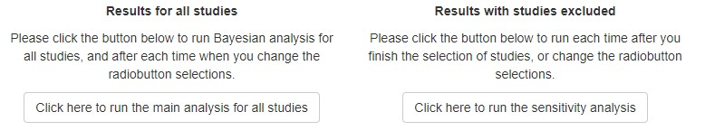

*Figure 19 Running buttons for Bayesian analysis*

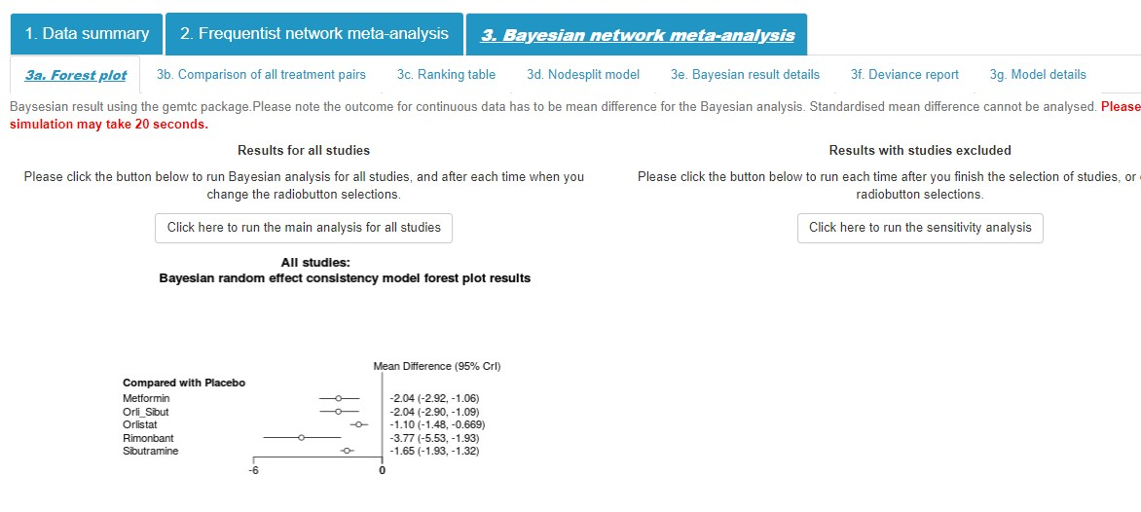

Always click here if you

change the model

specification and need to

re

-

run the model.

*Figure 20 Running button – always click to re-run whenever you change the selections on side bar*

Once the button to run the analysis has been clicked you will see the status bar on the right corner showing the progress of the analysis (Figure 21). Depending on the complexity of the model and the speed of your computer, the results usually take about 10 – 20 seconds to run, but can be up to 1 min, so please be patient and please do not re-click the button if the model is still running.

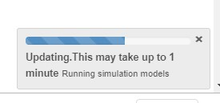

*Figure 21 Status bar indicating the model is running*

The Bayesian pages have the same layout as the frequentist pages, where the results from all studies are displayed side by side with the results from sensitivity analysis. Depending on the complexity of the network, it usually takes up to 1 minute for the results to display.

Similar to the frequentist result (Figure 16), the Bayesian result also shows that rimonbant has the largest pooled estimate compared with placebo but with large uncertainty depicted by the wider 95% credible interval. Frequentist results and Bayesian results do not necessarily agree with each other, for example, in some extreme situations where a lot of zero events exist in the binary data.

*Figure*

*22*

*forest plot results of Bayesian NMA*

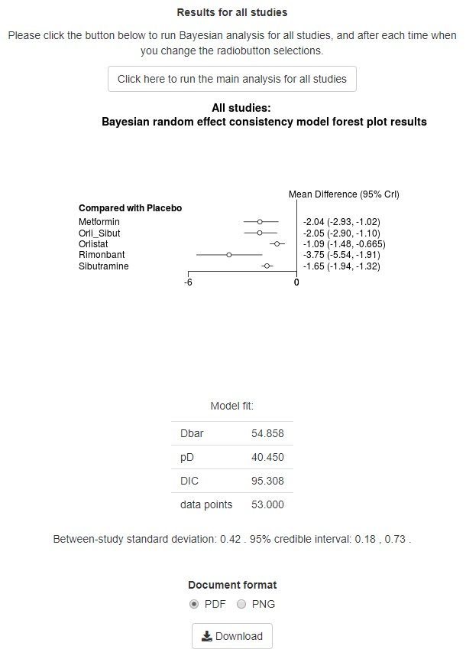

Model fit parameters

Underneath the forest plot are the model fit parameters (Figure 22). Dbar indicates the posterior mean of the deviance, and the pD is the effective number of parameters. The DIC is the sum of Dbar and pD. Lower values of the DIC suggest a more parsimonious model and therefore the DIC value could be used to select the most appropriate model(s). A rule of thumb is that differences in DIC over five are important, whereas a small differences (less than 3) suggests there was little difference between the models (10).

### Comparison of all treatment pairs

*Clicking the ‘3b. comparison of all treatment pairs’ tab will provide a table (Figure 23). This table shows the estimate from network meta-analysis only. This is different from the frequentist analysis where the pairwise estimates are displayed in the upper triangle. In the Bayesian comparison, the table displays the results for all treatment pairs in both the upper triangle and lower triangle, but with the comparison switched over; that is A vs. B or B vs. A. For both above and below the leading diagonal, the results are for the treatment at the top of the same column vs. treatment at the left hand side of the same row.*

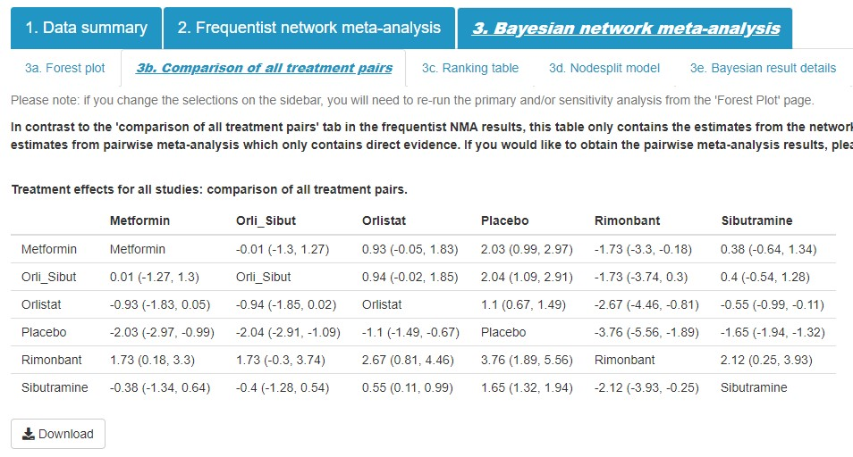

-

3.76:

rimonbant (treatment at

the same column) vs. placebo

(

treatment at the same row

)

*Figure 23 Comparison of all treatment pairs – Bayesian network meta-analysis*

Please note that this table of the Bayesian NMA is not ordered based on the ranking of the treatment effect. The ranking is shown on the tab ‘3c. ranking table’ (please see next section).

### Ranking table

Clicking on ‘3c. Ranking table’, we can see a ranking table on the left, and a median rank chart on the right. The ranking table shows the probability for each treatment to be ranked as the most effective treatment, ‘rank 1’, then second most effective treatment, ‘rank 2’, until the least effective treatment. For example, the probability metformin is ranked 1 is 0.7%, ranked 2 46.0%, ranked 3 33.9%, etc. With this table, you could calculate the Surface Under the Cumulative Ranking (SUCRA) (11), median rank, or mean rank.

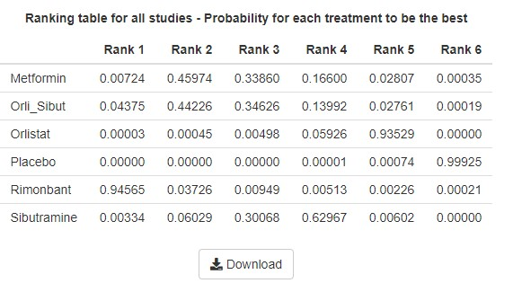

The median ra

nk for

metformin

*Figure 24 Ranking probability table: Probability for each treatment at each rank*

On the right is the median rank chart which visualises the median rank for each treatment. The median rank is the rank of the middle iteration when every simulated estimate of the rank is ordered. In this case, we run the simulation for 20000 iterations and monitor rank[4] (for metformin) and order the 20000 rank values obtained, then we look at the rank of the 10000th and 10001st iteration. In this case, it will be rank 3 for both 10000st and 10001st iterations for metformin, and therefore the median rank for metformin will be rank 3. Actually, in majority of the cases, the rank at 10000th and 10001st would be the same which will be used as the median rank. Very occasionally, when the rank for 10000th and 10001st are not the same, it will take an average of the two as the median rank.

Users can easily calculate the median rank themselves based on the table. To do this, you just need to add up the probabilities from the probability of being rank 1, rank 2, rank 3, until the sum is over 0.5, then the last rank you added will be the median rank.

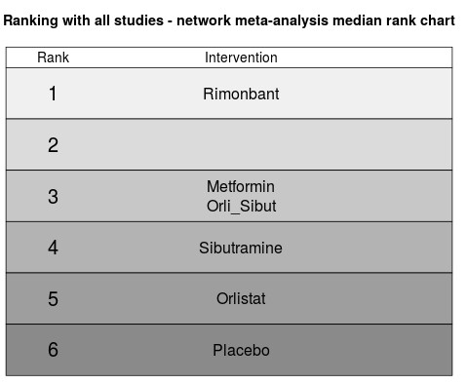

*Figure 25 Median rank chart*

### Nodesplit model

Next tab is the ‘nodesplit model’ where it runs the nodesplit model to check the inconsistency between direct evidence and indirect evidence. (12) This is a separate model from the main NMA model so no results will be displayed here until you click the button on this tab to run the nodesplit analysis. Clicking the button will start the analysis simulation and, same as the main analysis, you can see a status bar showing the model is running. It takes a much longer time to run than the initial NMA analysis as it fits a distinct model for each treatment pair in the network that has both direct and indirect evidence. The results are displayed in a very similar structure as the inconsistency checking for the frequentist analysis (Section 5.3.3) as shown in Figure 26. For each treatment comparison that has both direct and indirect estimates, the analysis will provide the mean and credible intervals (the value at 2.5% and 97.5% quantiles) for the direct, indirect and network estimates together with a Bayesian p-value for the related test of inconsistency between the direct and indirect evidence for each treatment comparison.

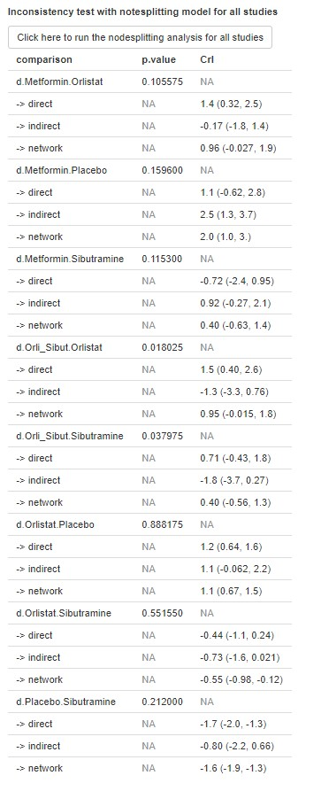

*Figure 26 Nodesplit model results*

### Bayesian result details

Clicking on the ‘Bayesian result details’ tab provides the direct R output from running the analysis based on the GeMTC package. Here, you can find more detail about the analysis and results used for the forest plot on tab ‘3a. forest plot’ as shown in Figure 27.

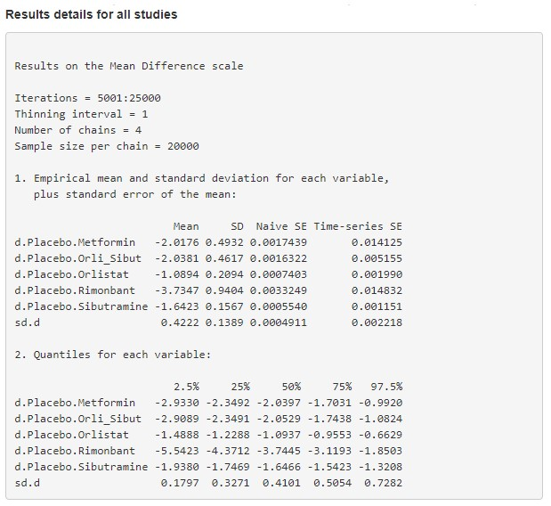

Burn

-

in for 5000, and

results are counted from

the 5001

st

interaction until

the 25000

th

.

These are the results

displaye

d on ‘3a. forest

pot’ tab.

*Figure 27 Results details of the Bayesian NMA primary analysis*

You can also obtain the Gelman-Rubin convergence assessment plots (Figure 28) for the Bayesian NMA model. This plot will be useful for checking the simulated model has converged – a requirement for valid analysis results. Broadly the red line on the plot should reach stability around the value 1 (as in Figure 27). Further details about this plot can be found elsewhere. (13)

The current version of the app uses default setting for the number of simulated iterations for burn-in (5000) and for the model results (20000). While we have observed evidence of convergence using these defaults for datasets we have tested, we hope to allow more flexibility in the future so that users can adjust the burn-in period and model results period (and perhaps the number of simulated chains run and their initial values) based on the Gelman convergence assessment plot.

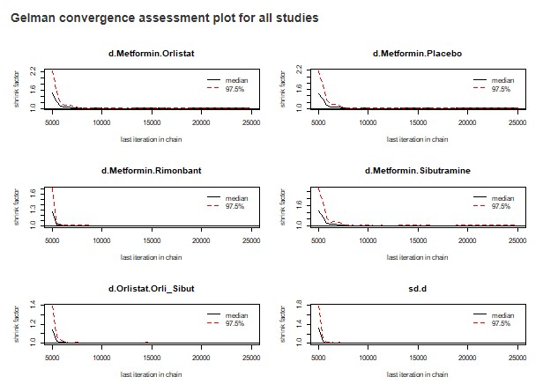

*Figure 28 Gelman convergence assessment plot*

### Deviance report

Next tab is the ‘3f. Deviance report’ which provides three interactive deviance checking plots, and deviance data output at the bottom. Once you enter this page, an unrelated mean effect (UME) inconsistency model (10) will immediately start running which will produce part of the results shown on the first plot. These plots are designed to be interactive so users can move cursors on the point to identify which study these outliers were from. The corresponding specific study and arm information will be displayed beside the point.

We will start by introducing the second and third plots as they are only contributed by the data from the primary model, and introducing the first (i.e. top) plot in the end, as it plotted the results from both the primary model and the inconsistency model.

The second plot (Figure 29) is the contribution for each study arm to the residual deviance. Ideally each point should contribute around one, with bigger values indicating poorer fit and thus higher residuals. Move your cursor to the three points that have a residual deviance larger than 2 and the corresponding study which contributed to the points will show. For the obesity example, study data points with high residual deviances are both study arms of Ozcelik 2004, and the 2nd arm of Borges 2007. Please note that arms from the same study are ordered from left to right, for example, the first data point on the left of this chart comes from the first arm of Aydin 2004, then towards the right, the second arm of Aydin 2004, and then the third arm of Aydin 2004.

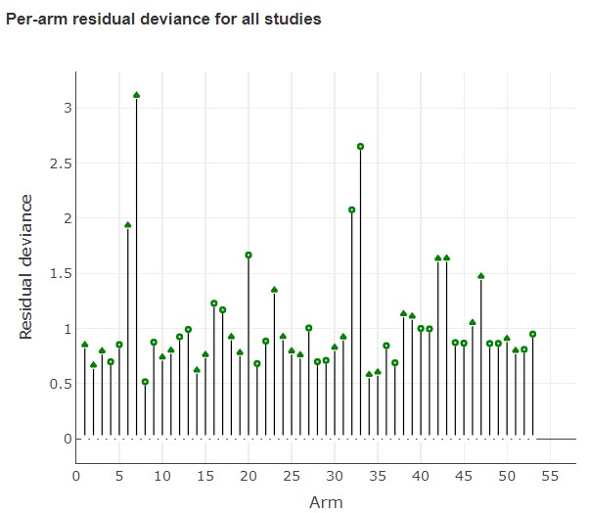

Circled points are

the high residual

deviance.

*Figure 29 Per-arm residual deviance for all studies*

It may be sensible to explore further the studies identified as having high residual deviances, checking no mistakes were made with data entry, exploring whether the studies differ from the others studies included in the NMA, whether the studies were poor quality and therefore at risk of bias. It may also be sensible to do a sensitivity analysis excluding these studies (note taking whole studies out not just individual arms) to assess the impact their omission has on the overall NMA results.

The contour plot in Figure 30 takes this a step further by simultaneously looking at residual deviance and leverage (which is a statistical measure of influence of a data point on model estimation) simultaneously. The text suggests leverage values outside the contour of 3 (which is a data points contribution to the DIC) are considered poorly fitting. In the obesity example two points are (just) outside 3. The points leverage values are not extreme, but it is the (square root) of the residual deviance which are - i.e. the 2 highest values - Ozcelik and Borges, which we can see by hovering cursor over the points.

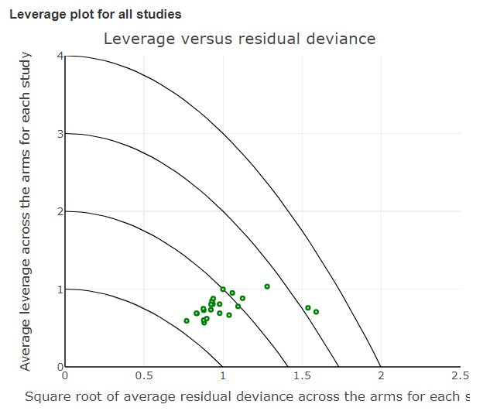

Circled poin

ts have a

leverage over 3, indicating

they have large influence.

*Figure 30 Leverage plot*

Now, we come back to the first plot (Figure 31). The first plot visualizes the level of inconsistency for each study arm separately in the analysis. It displays the residual deviance from an inconsistency model, against the residual deviance from the NMA model. For both models, the larger the residual deviance, the poorer the fit of that study arm data to the respective model. When the points are on the equality line (the dotted line on the plot), it means that relaxing the consistency assumption, by fitting an inconsistency model cannot improve the model fit and thus the deviance cannot be attributed to conflict between this and other study’s results when consistency is assumed. When points are below the line, it means, for that data point, the residual deviance from the NMA model is larger than for the inconsistency model, indicating that there may be some evidence of inconsistency.

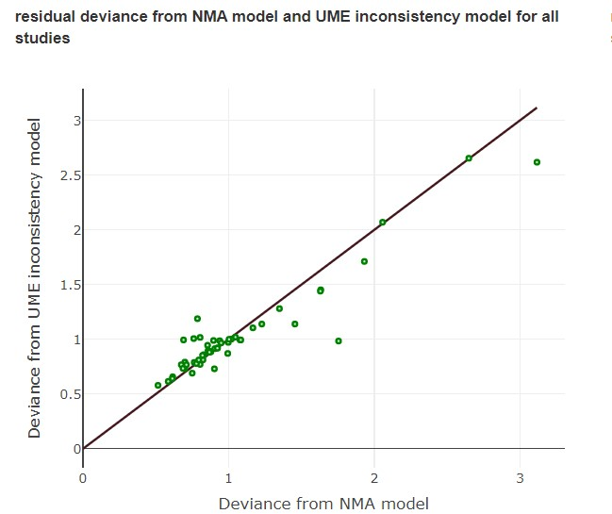

These are the

points

with larger residual

deviance (>2)

.

Equality line

*Figure 31 Residual deviance plot from NMA model and UME inconsistency model for all studies, on the ‘3f.deviance report’ page.*

For the inbuilt example (displayed in Figure 31), there are three points with residual deviances greater than 2. Two points are on the line indicating that the NMA model and inconsistency model both provide a similarly poor fit to these data points. The third point is in the very top right corner again showing poor model fit but it is below the equality line indicating the inconsistency model provides a better fit. Moving cursor to the points, we can see that the point in the very top right corner is from the study Borges 2007, and the other two points (with deviance >2) on the equality line are from Ozcelik 2004.

Users can also use the data table at ’3g. Model details’ – ‘3g-4. Deviance details’ to view the complete deviance data., where ‘dev.ab’ in the top table is the residual deviance for each trial arm from the NMA model (Figure 32) and ‘dev.ab’ in the bottom table is from the inconsistency UME model. Further investigation of these studies may be appropriate.

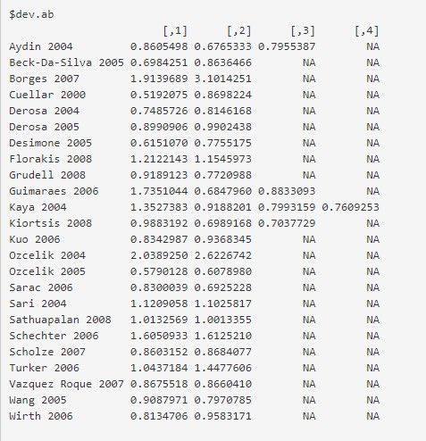

These are the

points

with larger residual

deviance (>2)

.

*Figure 32 Deviance data from the NMA model (please note the data may change due to the differences in each simulation)*

### Model details

Clicking on the last tab, ‘model details’ will provide additional details about the model (Figure 33). This page contains the information behind all the summary output, including model codes and initial values, and you can download the simulated output data (as produced by the JAGS package). These are primarily included to add transparency to the app and provide code that ensures any analysis is reproducible (good practice for data analysis), i.e. you could run this code directly in R to reproduce the results the app presents.

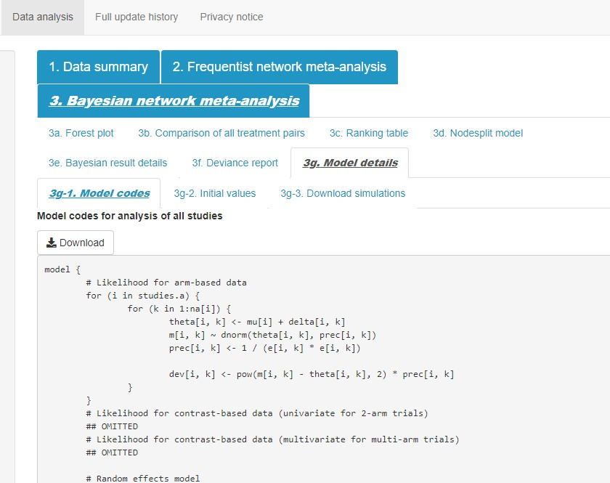

*Figure 33 Model details*

## Perform sensitivity analysis

The purpose of the inbuilt sensitivity analysis is to investigate the influence of the different studies on the NMA results. For instance, you may want to explore the impact on the results of excluding one or more studies with higher risk of bias, small sample size, with zero events (for binary outcomes), with slightly different population characteristics, intervention characteristics, high deviance or leverage, etc. to assess the robustness of the analysis results to such issues. Studies can easily be excluded from the analysis using a simple checkbox interface (Figure 34). The user can choose to exclude one or more studies and the NMA will be updated (for Bayesian NMA, the running button needs to be clicked to update the results) and displayed alongside the complete case analysis which remains visible to facilitate comparison. For illustrative purposes only, in this particular example, we have chosen to exclude 2 studies (Kaya 2004, and Sathuapalan 2008).

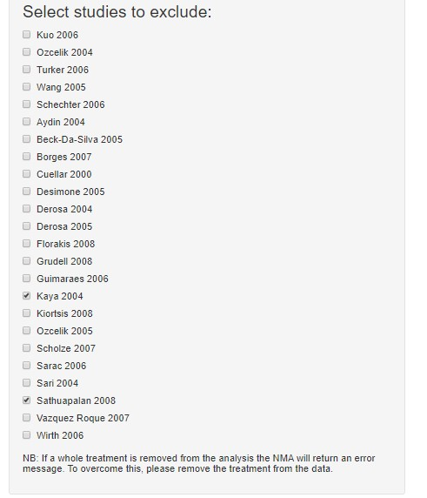

*Figure 34 Checkbox input for sensitivity analyses*

### Sensitivity analysis: network plots

Now, clicking on the ‘1. Data summary’ – ‘1b. Network plot’, as shown in Figure 35, you can see that the network plot with studies excluded on the right only contains five treatments, as the only study that contains rimonbant (Sathuapalan 2008) has been removed from the analysis and thus rimonbant is no longer connected to the network of evidence and has therefore disappeared from the network plot.

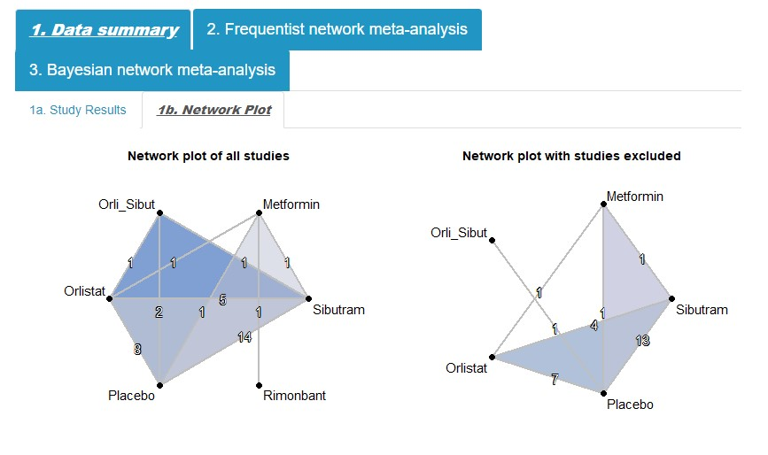

Kaya 2004 is a four-arm study comparing placebo, orlistat,

sibutramine, and orli_sibut. After removing Kaya 2004, the

number of trials on the line connecting each of these

treatment nodes was reduced by 1. After removing

Sathuapaian 2008 which compares rimonbant and

metformin, rimonbant disappeared from the network.

*Figure 35 Network plots illustrating the network plot including all studies to the right and the network plot of treatment comparisons after excluding studies to the right*

### Sensitivity analysis: forest plots

Similarly, summary forest plots (together with the number of studies included, number of treatments and the estimated between-study standard deviation) can be displayed for all studies and with selected studies excluded (Figure 36). Now with the exclusion of the

Sathuapalan 2008 study, rimonbant as a treatment has disappeared from the forest plot (displayed in the right). With the exclusion of the Kaya 2004 study, the incremental effectiveness of ‘orli_sibut’ versus placebo became almost zero, with very large uncertainty (i.e. very large confidence intervals). Click on the ‘1. Data summary’ – ‘1a. Study results’, then uncheck the Kaya 2004 study, you will see that it provides very certain positive evidence for the comparison ‘Orli_sibut’ versus placebo whereas the other study (Borges 2007) provides an indifferent result. This confirms that after excluding Kaya 2004, the pooled result for this comparison becomes uncertain.

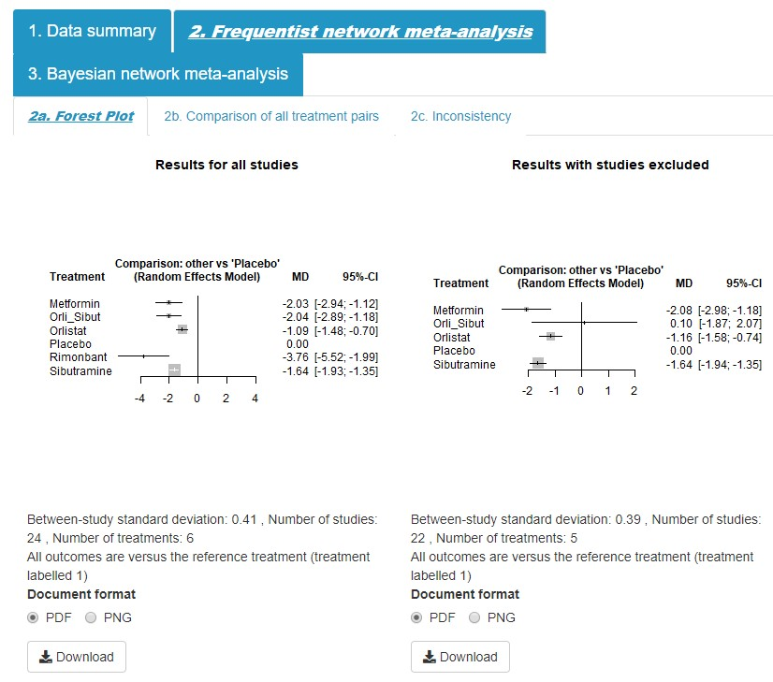

There were two trials (Kaya 2004 and Borges 2007) providing

direct evidence for the comparison between orli_sibut and

placebo. Kaya 2004 shows a strong evidence that orli_sibut was

more effective than the

placebo while the other (Borges 2007)

shows no difference. This can be observed from the ‘1a. study

results’ tab. After excluding Kaya 2004 in the sensitivity

analysis, the estimate for this comparison became uncertain.

*Figure 36 Forest plots from frequentist NMA illustrating the results of treatment comparisons including all studies to the left, and results with studies excluded to the right*

Click the ‘3. Bayesian network meta-analysis’ tab, and under the ‘3a. forest plot’ tab, click the button to run the sensitivity analysis (Figure 37).

41

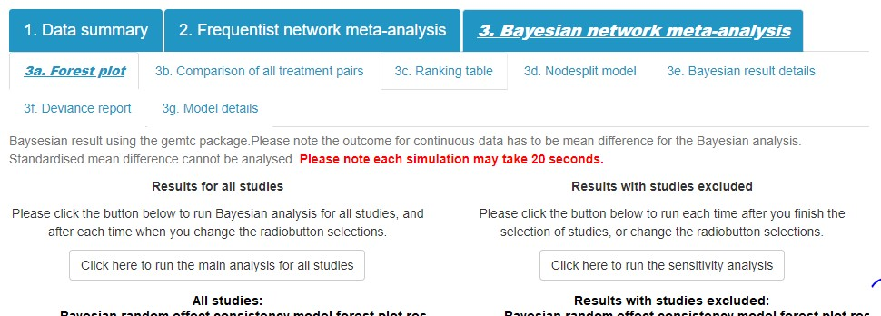

Click this button to run sensitivity

analysis of

Bayesian NMA

*Figure 37 Running button for Bayesian sensitivity analysis*

The Bayesian NMA sensitivity analysis provided similar results as the frequentist analysis as shown in Figure 38, where the Orli_sibut is no longer more effective compared to placebo.

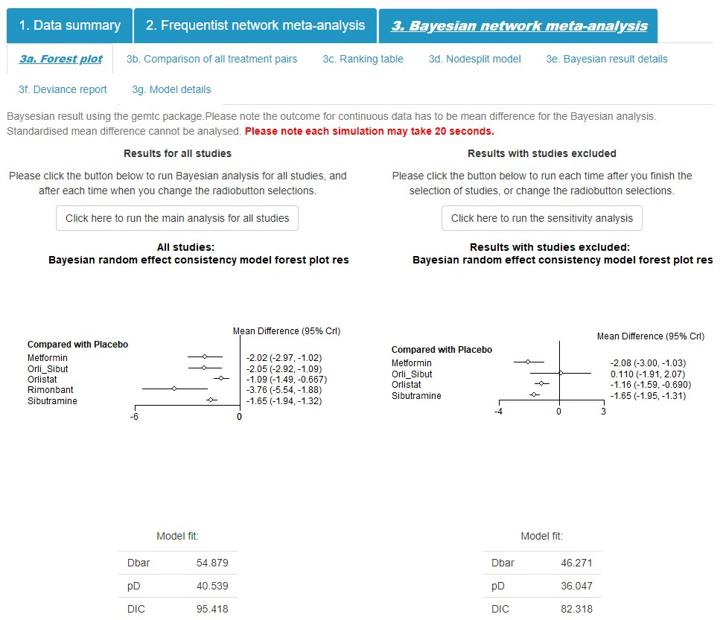

Similar results as the frequentist

analysis shown in

Figure

36

.

*Figure 38 Forest plots from Bayesian NMA illustrating the results of treatment comparisons including all studies to the left, and results with studies excluded to the right*

### Sensitivity analysis: comparison of all treatment pairs

Coming back to the frequentist analysis, with the two studies excluded (checked on the ‘select studies to exclude’ list), click on ‘2b. comparison of all treatment pairs’, you will see the comparison table as presented in Figure 39. Kaya 2004 provides a direct comparison between orli_sibut and orlistat, which closes the loop for ‘orlistat – placebo - orli_sibut’

(Figure 35 to the left). After excluding Kaya 2004, Orli_sibut was no longer in the loop (Figure

35 to the right), and therefore there was no longer indirect evidence contributing to the estimate for orli_sibut versus placebo; the network estimate for orli_sibut versus placebo becomes the same as the direct estimate (0.10, 95% CI -1.87, 2.07).

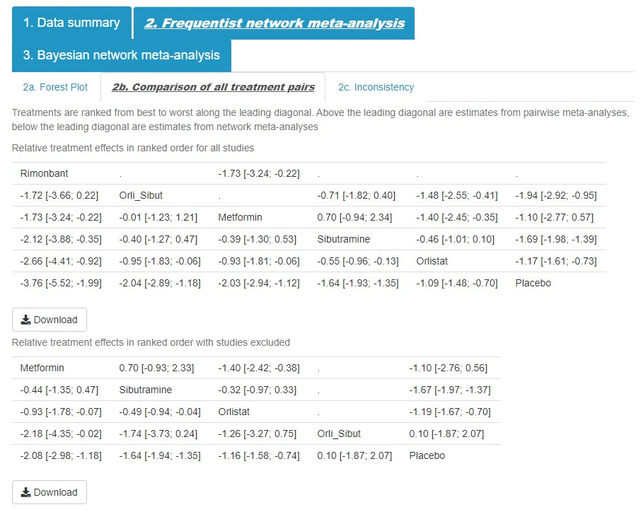

Aft

er excluding

Kaya 2004,

orli_sib vs.

placebo was no

longer in a

closed loop and

thus indirect

evidence no

longer exists and

the network

pooled estimate

is the same as

the estimate

from direct

evidence only.

*Figure 39 Comparison table illustrating the all treatment pairs comparison including all studies at the top, and results with studies excluded at the bottom*

### Sensitivity analysis: ranking

The treatment rankings also changed after removing these two studies. It can be observed that after removing rimonbant from the ranking, the most effective treatment becomes metformin (table below), compared to the previous orli_sibut in the table above. Orli_Sibut moves from the second most effective treatment to the second least effective treatment, with very a similar treatment effect as placebo. The order for the other treatments did not change, i.e. metformin, sibutramine, orlistat and placebo.



Original ranking for orli_sibut: second

most effective treatment

Ranking changed for

orli_s

ibut: second least

effective treatment

Excluded from the

analysis

*Figure 40 Comparison table illustrating the all treatment pairs comparison including all studies at the top, and results with studies excluded at the bottom: ranking changed*

This change in the rankings is also reflected in the Bayesian ‘3c. Ranking table’. Clicking ‘3. Bayesian network meta-analysis’, then ‘3c. Ranking table’ will bring us directly to the results of the rankings. As shown in Figure 41, the ranking is very slightly different from the frequentist results where the orli_sibut is ranked in last place, i.e. least effective, compared to the frequentist results where orli_sibut is ranked before placebo. This is not so surprising given the estimate is so close to 0 with a very wide confidence interval.

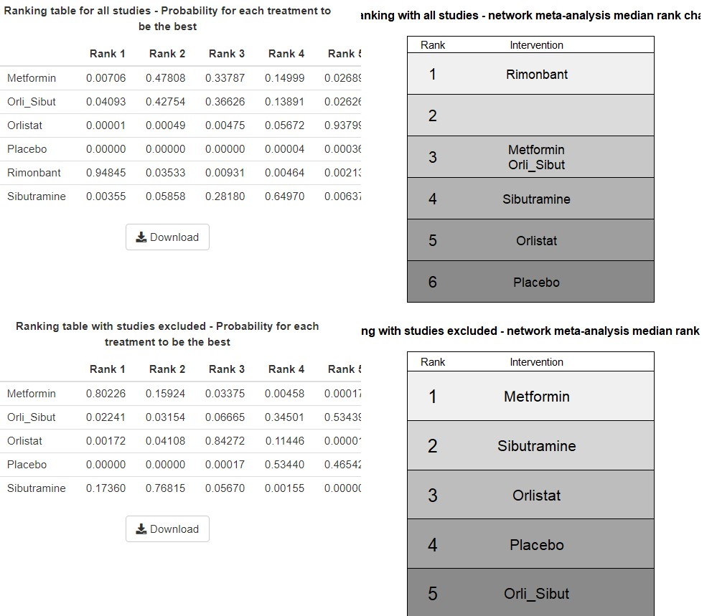

*Figure 41 Sensitivity analysis of Bayesian NMA: ranking table*

### Sensitivity analysis: Inconsistency

Assessment of inconsistency between direct and indirect evidence could also be evaluated after excluding studies for both frequentist NMA and Bayesian NMA. Figure 42 provides the inconsistency assessment results for all studies at the top and with studies excluded at the bottom for frequentist NMA and Figure 43 provides the inconsistency results for all studies on the left and with studies excluded on the right Note, the number of the rows in the table was reduced after excluding the two studies. This is because one treatment (Rimonbant) was removed from the network. There was no evidence of inconsistency observed for both the full network and the reduced network, for both frequentist and Bayesian NMA.

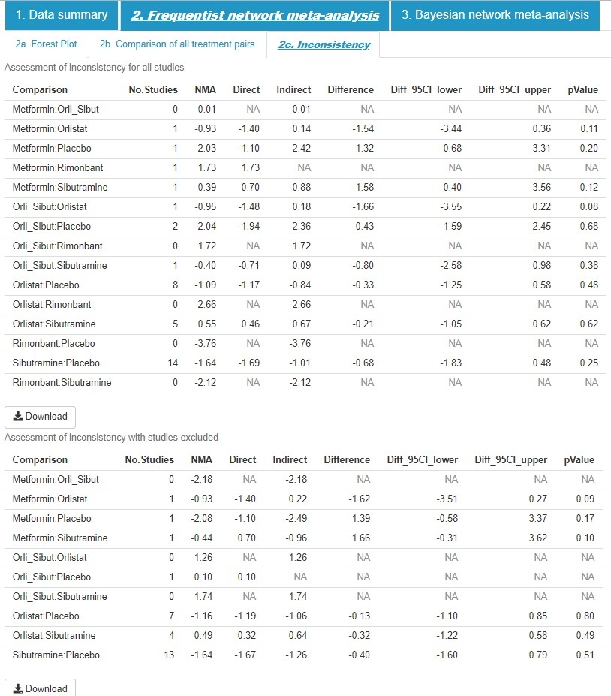

*Figure 42 Inconsistency table illustrating the estimates including all studies at the top, and results with studies excluded at the bottom*

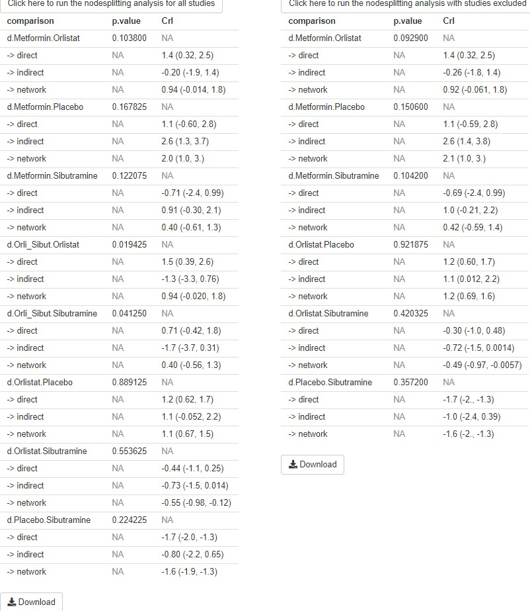

*Figure 43 Sensitivity analysis of Bayesian NMA: nodesplit model.*

### Sensitivity analysis: Bayesian details and deviance report

Additionally, the Bayesian NMA also provides Bayesian details (Figure 44) and deviance report for the sensitivity analysis with studies excluded.

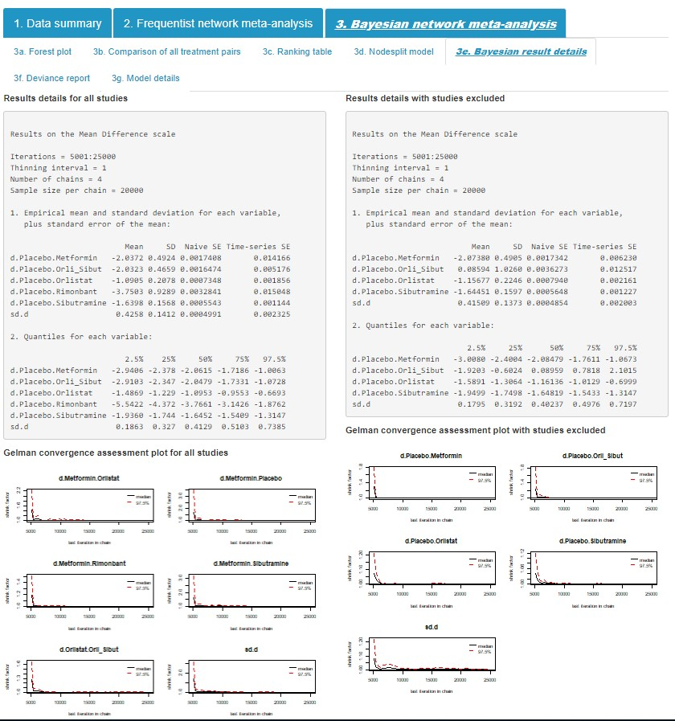

*Figure 44 Sensitivity analysis: Bayesian result details*

Model fit did not change very much but it can be observed that in the sensitivity analysis the data points from Borge 2007 no longer produce large residual deviances. This could be explained by looking at the treatments trialled in Borge 2007 and the excluded trials. It suggests that the excluded trials (Kaya 2004, and Sathuapalan 2008) had data on the same treatment comparison or in a loop with the treatment comparison with Borge and the data were in conflict to some degree, causing the large deviance. Please note that although excluding studies may reduce the deviance of the remaining studies in the network, this does not necessarily mean the excluded studies are ‘biased’, or ‘wrong’, it just means they are in conflict with the remaining studies.

*Figure*

*45*

*Sensitivity analysis*

*:*

*Deviance report*

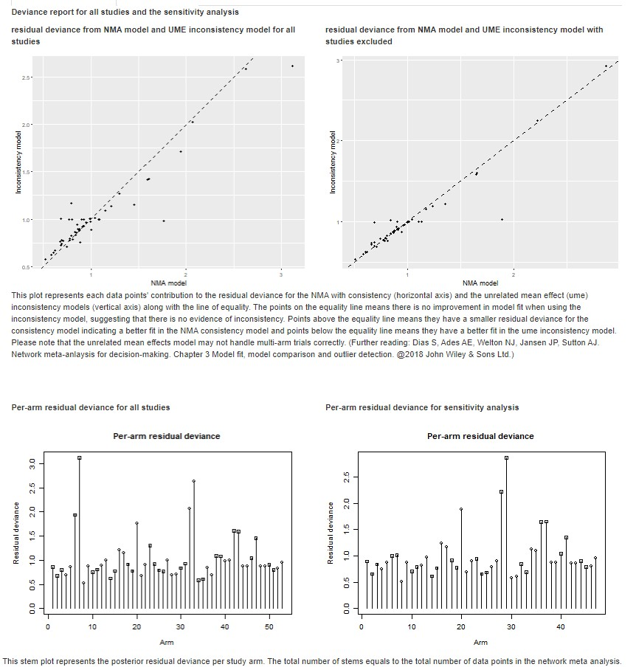

These outliers were no

longer shown in the

sensitivity analysis.

## Output results

Each part of the output can be individually downloaded from the app. Depending on the type of the result, below the output, the user has the option to download results as a portable document format (PDF), portable network graphic (PNG), for study results, a scalar vector graphic (SVG), or for tables, a comma-separated values (CSV) file (Figure 46). The ability to output results allows the user to include the produced figures directly in their NMA report.

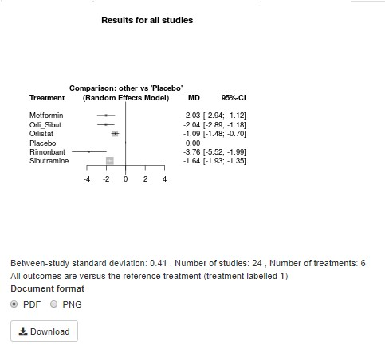

*Figure 46 Download buttons to output results: an example*

# Acknowledgement

This project was funded by the UK National Institute for Health Research (Grant/Award Number: 14/178/29). We are thankful to our colleagues, Naomi Bradbury, who was involved in the development of the app. We are also grateful to Dikshyanta Rana for providing feedback on a draft of the user manual.

# Full list of packages

|  |  |
| --- | --- |
| **Package name** | **Version** |
| dplyr | 0.8.5 |
| knitr | 1.28 |
| plyr | 1.8.6 |
| data.table | 1.12.8 |
| ggplot2 | 3.3.0 |
| metafor | 2.1.0 |
| gemtc | 0.8.4 |
| netmeta | 1.2.1 |
| BUGSnet | 1.0.3 |
| shiny | 1.4.0 |
| shinydashboard | 0.7.1 |
| shinyAce | 0.4.1 |
| rmarkdown | 2.1 |
| shinyalert | 1.0 |
| plotly | 4.9.1 |
| shinyjs | 1.1 |
| shinyWidgets | 0.5.1 |
| shinyBS | 0.5.1 |

# References

1. Caldwell DM, Ades AE, Higgins JP. Simultaneous comparison of multiple treatments: combining direct and indirect evidence. Bmj. 2005;331(7521):897-900.
2. Hoaglin DC, Hawkins N, Jansen JP, Scott DA, Itzler R, Cappelleri JC, et al. Conducting Indirect-Treatment-Comparison and Network-Meta-Analysis Studies: Report of the ISPOR Task Force on Indirect Treatment Comparisons Good Research Practices: Part 2. Value in Health. 2011;14(4):429-37.
3. Lu G, Ades AE. Combination of direct and indirect evidence in mixed treatment comparisons. Stat Med. 2004;23(20):3105-24.
4. Lumley T. Network meta-analysis for indirect treatment comparisons. Statistics in Medicine. 2002;21(16):2313-24.
5. Chang W, Cheng J, Allaire J, J., Xie Y, McPherson J, RStudio., et al. shiny: Web Application Framework for R 2019 [Available from: [https://cran.rproject.org/web/packages/shiny/index.html.](https://cran.r-project.org/web/packages/shiny/index.html)
6. Rücker GS, G.; Krahn, U.; König, J. netmeta: Network Meta-Analysis using Frequentist Methods. 2017.
7. van Valkenhoef G, Kuiper J. Package ‘gemtc’. Network Meta-Analysis Using Bayesian Methods. Version 0.8 - 2. 2016 [Available from: [https://cran.rproject.org/web/packages/gemtc/gemtc.pdf.](https://cran.r-project.org/web/packages/gemtc/gemtc.pdf)
8. Gray LJ, Cooper N, Dunkley A, Warren FC, Ara R, Abrams K, et al. A systematic review and mixed treatment comparison of pharmacological interventions for the treatment of obesity. Obesity reviews. 2012;13(6):483-98.
9. Riley RD, Higgins JPT, Deeks JJ. Interpretation of random effects meta-analyses. BMJ. 2011;342:d549.
10. Dias S, Ades AE, Welton NJ, Jansen JP, Sutton AJ. Chapter 3. Model Fit, Model Comparison and Outlier Detection. Network Meta‐Analysis for Decision Making. 2018:59-91. 11. Mbuagbaw L, Rochwerg B, Jaeschke R, Heels-Andsell D, Alhazzani W, Thabane L, et al. Approaches to interpreting and choosing the best treatments in network meta-analyses.

Systematic Reviews. 2017;6(1):79.

1. Dias S, Welton NJ, Caldwell DM, Ades AE. Checking consistency in mixed treatment comparison meta-analysis. Stat Med. 2010;29(7-8):932-44.
2. Welton NJ, Sutton AJ, Cooper NJ, Abrams KR, Ades AE. Bayesian Methods and WinBUGS. Evidence Synthesis for Decision Making in Healthcare. Wiley Online Books2012. p. 17-42.